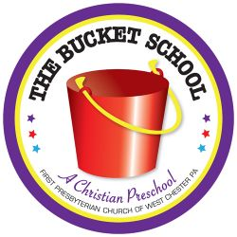

PRE-K LEARNERS PROGRAM- 4/5 YR. OLDS

Our Pre-K program is designed to prepare children for kindergarten and serve as a foundation for later learning. Curriculum focuses on cognitive learning, social and emotional development, language acquisition, and small and large motor skills. The following are some skills that are worked on through the year.

Social Skills:
Put on coat independently Button, snap, and zip clothes
Use bathroom independently Listen to others when it is their turn to talk
Verbally express needs and wants Follow simple directions
Attend to a task independently Help with pick-up and cleanup
Interact with other children appropriately Take turns and share

Language/Pre-Reading Skills:
Speak in complete sentences Use books appropriately
Anticipate what will “happen next” in a story Recall and sequence events from a story that has been read
Identify words that rhyme Recite rhymes and sing songs independently and with group
Identify the letters of the alphabet Tell how things are alike and different
Understand simple opposites Understand positional concepts

Math/Science Skills:
Identify and create simple patterns Be familiar with days of the week, month, holidays, and weather
Identify primary and secondary shapes Copy simple shapes (square, cross, circle, and triangle)
Rote count up to twenty Identify numbers 1 – 20
Identify and sequence numbers from one to ten Recognize number sets from one to ten

Fine Motor Skills:
Use pencil, crayon, and marker with control
Use scissors with control following straight and curved lines
String beads
Trace a line or a simple design
Print first name correctly
Print upper and lower case letters, print numbers 1 – 10

Gross Motor Skills:
Throw and catch a ball with control
Run, hop, skip, and jump
Participate in simple group games

All of the above skills are gently incorporated throughout our day into circle time, creative play, music, art and story time. Every child learns differently and will develop these skills at a different rate.
We will be scheduling a conference at the end of January to meet with you and discuss your child’s progress and school experience. We look forward to getting to know you and your child!

